Getting a Job
Read the following job advertisement and complete:

- Supplies / provide
- Service centers
- Provide
- Spreadsheet and database
- Launched
- Client
- Installing / Maintaining
- Maintaining/Installing
- Diagnosing
- From time to time

[활동]
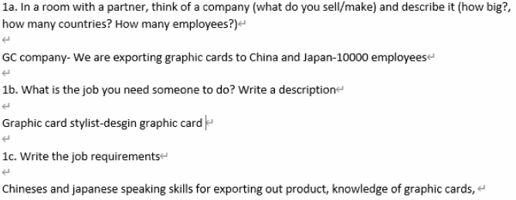

Open Source Software

spreadsheets one stores operating free processors secret
proprietary software design vendors features

With open source software, what do people think about first? Money, usually, because open source software is free But this isn’t the only important thing. First, there is freedom from the software vendors. Organisations say that freedom is the number one reason to choose open source software. With open source software, an organisation doesn’t have to follow the software vendor’s decisions. With proprietary software the vendor controls software updates. For example, users can’t add features to proprietary software themselves but they can add features to open source software.

Also with open source software companies have more control of their data. Proprietary software often stores data in special ways that only the vendor understands. So, when a company wants to change to another vendor’s software, moving the data to the new software can be very difficult. Open source software is different; open source software vendors explain their data clearly and openly so that they are not a secret. Because of this, moving data isn’t a problem.

Sometimes people worry about open source operating systems. They think that their favourite software won’t run on open source operating systems. However, this isn’t true because there is a lot of office software, such as word processors and spreadsheets, for open source operating systems. In fact, there are many kinds of this software and they work well. It is only special areas, such as graphics design, where proprietary software is clearly better.

Comprehension:
- What are the three benefits to using open source software?
- Free, freedom from vendor, data control
- What is the main worry about open source operating systems?
- Software incompatibility
- When is proprietary software clearly better according to the article?
- Speacial areas; e.g. graphics design
Listening:
What reasons does the speaker give against using open source software? Complete.
- Not sheap
  - Training b. Support
- Proprietary software is made by paid employees
- Most software doesn’t run on open source OS

Language: Making Recommendations 1

I think that we should get a new mouse.
I think that it’s a good idea to get a new mouse.
In my opinion, It’s best to get a new mouse

I recommend getting a new mouse.
I’d recomnemd that we get a new mouse.
I recommend a new mouse.

Gerund = verb+ing (verb => noun)
Clause = sentence (S+V+O)

Practice: Write these recommendations out in full using one pattern from each row (TWO recommendations for each activity):
- Buy a new smartphone
I think that we should buy a new smartphone.
I think that it’s a good idea to buy a new smartphone.
In my opinion, It’s best to buy a new smartphone.

- Upgrade to Windows 2018
___________________________________________________________________
___________________________________________________________________
- Hire a new employee
___________________________________________________________________
___________________________________________________________________
- Samsung Galaxy Note 10 (Just ONE recommendation. Hint: use the noun form)

Speaking Activity:

Devices : iphone, computer
App : zoom - easy to use, every time - easy to see the timetable

I recommend getting a iphone11. because the app run fast.
I recommend using the Everytime app. because it is convenient to see the timetable.

Making Recommendations 2

Listening:
Listen to the three people talk about their companies. How big is each company?

Company 1: __________________ | Company 2: __________________ | Company 3: __________________

Listen again and take notes on each company’s CAD requirements:

Company 1: _____________________________________________________________________
_______________________________________________________________________________
_______________________________________________________________________________
_______________________________________________________________________________

Company 2: _____________________________________________________________________
_______________________________________________________________________________
_______________________________________________________________________________
_______________________________________________________________________________

Company 3: _____________________________________________________________________
_______________________________________________________________________________
_______________________________________________________________________________
_______________________________________________________________________________

Which of the following CAD packages is best for each company?

